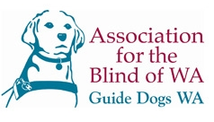
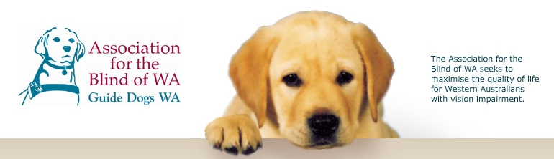

Module 1 – Eye Health

This Module links directly with Health and Science based outcomes through the exploration of the eye, the different types of eye damage that can occur, and the ways in which blindness can be prevented through a variety of simple techniques such as good diet and wearing sunglasses.

The following information has been drawn from the Western Australian Curriculum Framework Document and associated Curriculum Guidelines to help teachers place the module in context.

SCIENCE LEARNING AREA STATEMENTS
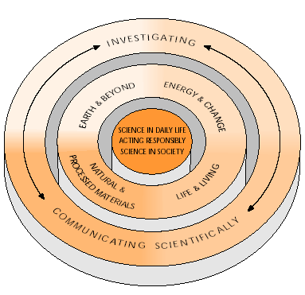

SCIENCE IN DAILY LIFE
Students select and apply scientific knowledge, skills and understandings across a range of contexts in daily life.

.…They identify relevant scientific concepts to explain the operation of tools and appliances, farms and gardens, industrial processes, and health and hygiene….

…..They give appropriate scientific explanations for safe procedures, such as those used in storing household chemicals, lighting camp fires, refueling an engine, or handling animals. Students routinely read labels and practice safe procedures in handling all substances in the home, garden and workplace, including cleaners, solvents, medicines and fuels, as well as known toxins, such as herbicides and pesticides.

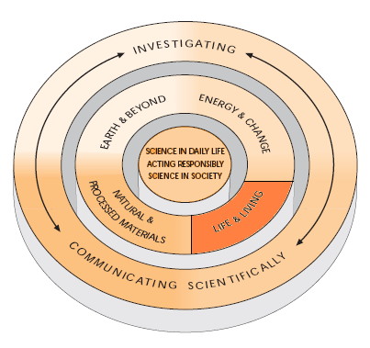
LIFE AND LIVING
….Students understand their own biology and that of other living things, and recognise the interdependence of life….

…..Students understand the relationship between structure and function in living things and use that as a basis for understanding life-maintaining processes…...

…..They identify the characteristics of living and non-living things. They recognise themselves as living things and give examples of their needs and the characteristics that identify them as living….

…….Students describe how living things function as whole organisms and explain the relationship between structure and function in systems, organs, tissues and cell....

…....They know about the effects of disease and how to maintain a healthy lifestyle….

HEALTH AND PHYSICAL EDUCATION
LEARNING AREA STATEMENTS
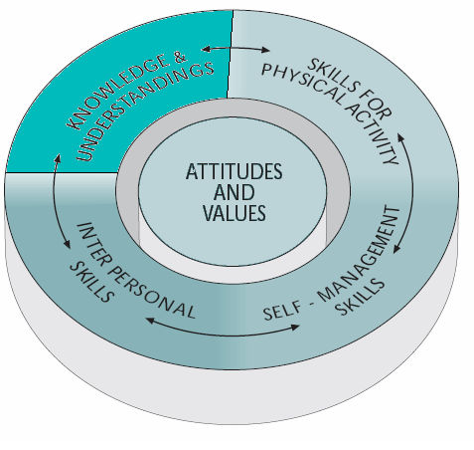

KNOWLEDGE &UNDERSTANDINGS

….Students know and understand health and physical activity concepts that enable informed decisions for a healthy, active lifestyle…..

….Through knowledge and understandings of key concepts, students are informed and take a critical perspective on health and physical activity issues within family, school, community and work settings….

….Students know the essential health concepts and understand the importance of a balanced lifestyle that takes into account work, leisure and recreation….

….They know and understand, for example, vital concepts related to growth and development….hygiene, communicable disease …. First aid and injury prevention.

…Students learn and understand the roles of relevant health agencies and how and when to access them…..

….Students comprehend the various social, cultural, environmental and political factors that influence an individual’s well-being and participation in physical activity….

….They recognise that not all groups in society have similar health status or access to health care, sport and recreational opportunities…..

ATTITUDES AND VALUES
….Students exhibit attitudes and values that promote personal, family and community health, and participation in physical activity….

…..Students identify attitudes and values for a healthy active, lifestyle and demonstrate values consistent with the prevention of ill-health, the acceptance of personal responsibility for their health and physical activity levels, respect for social justice principles and a commitment to personal achievement….

…..Students recognise and value, safe and supportive environments…..

…..They demonstrate support for structures such as family, friendship groups, religious groups, support agencies and sporting teams…...

…..They exhibit safe practice in the classroom, in play and in games, and observe occupational health and safety guidelines where appropriate…

..…Students recognise and respect the principles of social justice. They demonstrate this by being inclusive and just in their interpersonal relationships in classroom, peer, friendship and team situations. They know and protect their own rights and respect the rights of others…..

…..In physical activity and sport, they recognise inequities and do not discriminate on the grounds of gender, race, culture, physical or mental disability or experiential background. Their actions reflect ethical considerations and a desire to rectify inequities that exist in school, social and sporting settings……

